Практическая работа 10

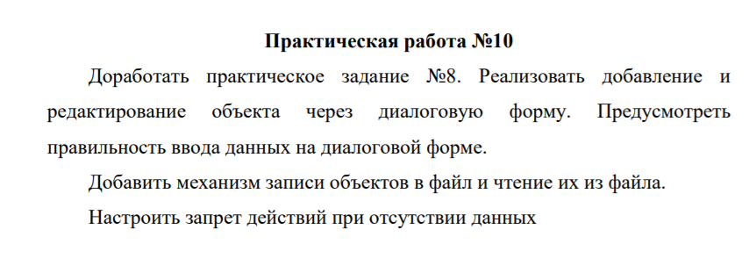

1.Form1

1.1 Внешний вид

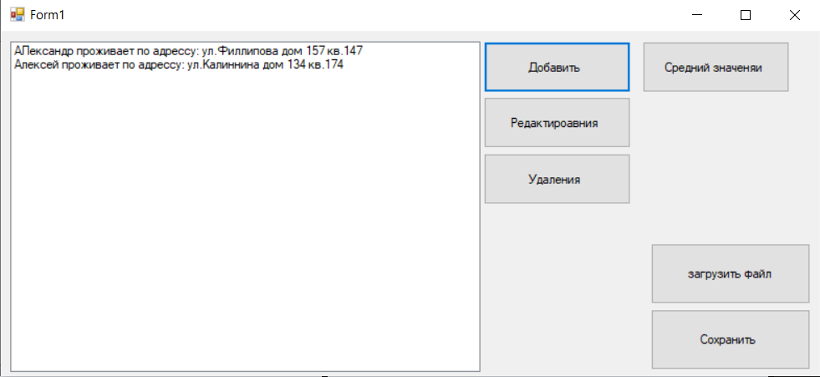

1.2 Код

using System;

using System.Collections.Generic;

using System.ComponentModel;

using System.Data;

using System.Drawing;

using System.Linq;

using System.Text;

using System.Threading.Tasks;

using System.Windows.Forms;

using System.IO;

namespace Практичекая_работа_9

{

public partial class Form1 : Form

{

public Form1()

{

InitializeComponent();

}

private void button1_Click(object sender, EventArgs e)

{

Form2 f = new Form2();

if (f.ShowDialog() == DialogResult.OK)

{

people p = new people();

p.FIO = f.textBox1.Text;

p.ul = f.textBox2.Text;

p.dom = Convert.ToInt32(f.textBox3.Text);

p.kv = Convert.ToInt32(f.textBox4.Text);

listBox1.Items.Add(p);

button2.Enabled = true;

button3.Enabled = true;

}

}

private void Form1_Load(object sender, EventArgs e)

{

button2.Enabled = false;

button3.Enabled = false;

}

private void button2_Click(object sender, EventArgs e)

{

Form3 f2 = new Form3();

if (listBox1.SelectedIndex == -1)

{

MessageBox.Show("Объект для редоктирования не выбран ");

}

else

{

int k = listBox1.SelectedIndex;

people p = listBox1.Items[k] as people;

f2.textBox1.Text = p.FIO;

f2.textBox2.Text = p.ul;

f2.textBox3.Text = p.dom.ToString();

f2.textBox4.Text = p.kv.ToString();

if (f2.ShowDialog() == DialogResult.OK)

{

p.FIO = f2.textBox1.Text;

p.ul = f2.textBox2.Text;

p.dom = Convert.ToInt32(f2.textBox3.Text);

p.kv = Convert.ToInt32(f2.textBox4.Text);

listBox1.Items[k] = p;

}

}

}

private void button4_Click(object sender, EventArgs e)

{

if (saveFileDialog1.ShowDialog() == DialogResult.OK)

{

StreamWriter sw = new StreamWriter(saveFileDialog1.FileName);

for(int i = 0; i < listBox1.Items.Count; i++)

{

people p=listBox1.Items[i] as people;

sw.WriteLine(p.FIO);

sw.WriteLine(p.ul);

sw.WriteLine(p.dom);

sw.WriteLine(p.kv);

}

sw.Close();

}

}

private void button3_Click(object sender, EventArgs e)

{

Form4 f = new Form4();

if (f.ShowDialog() == DialogResult.OK)

{

if (listBox1.SelectedIndex == -1)

{

MessageBox.Show("Объект для удаления не выбран");

}

else

{

int n = listBox1.SelectedIndex;

listBox1.Items.RemoveAt(n);

if (listBox1.SelectedIndex == 0)

{

button2.Enabled = false;

button3.Enabled = false;

}

}

}

}

private void Form1_FormClosing(object sender, FormClosingEventArgs e)

{

}

private void button5_Click(object sender, EventArgs e)

{

if (openFileDialog1.ShowDialog() == DialogResult.OK)

{

StreamReader sr = new StreamReader(openFileDialog1.FileName);

while (!sr.EndOfStream)

{

people p =new people();

p.FIO = sr.ReadLine();

p.ul = sr.ReadLine();

p.dom = Convert.ToInt32(sr.ReadLine());

p.kv = Convert.ToInt32(sr.ReadLine());

listBox1.Items.Add(p);

}

sr.Close();

}

}

private void button6_Click(object sender, EventArgs e)

{

Form5 f = new Form5();

if (f.ShowDialog() == DialogResult.OK)

{

double n = 0;

double n1 = 0;

if (f.checkBox1.Checked==true&& f.checkBox2.Checked == false)

{

for (int i = 0; i < listBox1.Items.Count; i++)

{

people p = listBox1.Items[i] as people;

n = n + p.dom;

}

double k = listBox1.Items.Count;

MessageBox.Show("Средние значение дома "+Convert.ToString(n/k*1.0));

}

else if(f.checkBox1.Checked == false && f.checkBox2.Checked == true)

{

for (int i = 0; i < listBox1.Items.Count; i++)

{

people p = listBox1.Items[i] as people;

n = n + p.kv;

}

double k = listBox1.Items.Count;

MessageBox.Show(" среднее значение квартиры "+Convert.ToString(n / k * 1.0));

}

else if (f.checkBox1.Checked == true && f.checkBox2.Checked == true)

{

for (int i = 0; i < listBox1.Items.Count; i++)

{

people p = listBox1.Items[i] as people;

n = n + p.dom;

n1 = n1 + p.kv;

}

double k = listBox1.Items.Count;

MessageBox.Show("Среднее значение дома " + Convert.ToString(n / k * 1.0+ "\r\n" +

"Среднее значение квартиры " + Convert.ToString(n1 / k * 1.0)));

}

}

}

}

}

2.Form2

2.1 Внешний вид

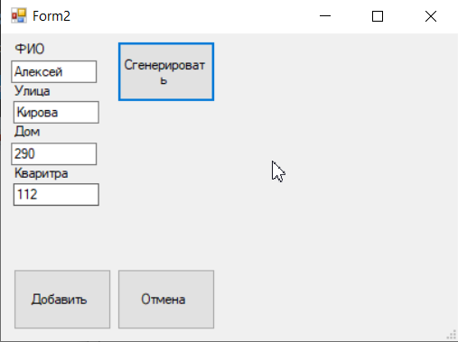

2.1 Код

int k = 0;

try

{

if (textBox1.Text == "")

{

throw new Exception("Вы не ввели ФИО ");

}

int r = Convert.ToInt32(textBox3.Text);

k++;

double t= Convert.ToDouble(textBox4.Text);

}

catch(FormatException)

{

if (k == 0)

{

MessageBox.Show("Номер дома должен быть указан циферно ");

textBox3.Focus();

}

else if (k == 1)

{

MessageBox.Show("Номер квартиры должен быть указан циферно ");

textBox4.Focus();

}

e.Cancel = true;

}

catch(Exception E)

{

MessageBox.Show(E.Message);

e.Cancel = true;

textBox1.Focus();

}

try

{

if (textBox2.Text == "")

{

throw new Exception("Вы не ввели Улицу ");

}

}

catch(Exception ex)

{

MessageBox.Show(ex.Message);

textBox2.Focus();

e.Cancel = true;

}

3. Form3

3.1 Внешний вид

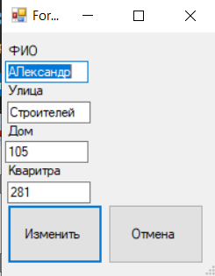

4. Form4

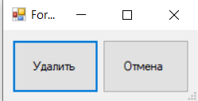

5. Form 5

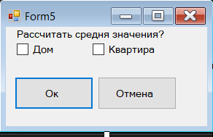

6.GitHub

<https://github.com/RgorkaK9/-10.git>